**DELIVERABLE 1- PROPOSAL**

**Project Title:**

On Campus Time Sheet and Payroll Management System

**Group Name:**

Brainstormers

**Group Members:**

1. Vaishnavi Mandadi (Group Leader)

2. Kiran jyothi bodduluri

3. Sahit Reddy Chinthakuntla

4. Rajashekhar Reddy Moddu

5. Venkata Sai Reshma kallepalli

6. Akshaya Sampelli

7. Aishwarya Yadav Jala

**Project Description:**

***On Campus Time Sheet and Payroll Management System*** is a web application used by universities for managing the part time jobs of students with the help of time sheets and payroll management by managers. Managers can use this application to allot the time sheets to the students about their works and also in the background the application calculates the working hours and payments with taxes. The system also generates reports such as weekly or monthly pay list, pay slips etc. Students can use this application to manage their working hours and payroll. In this application students can also post cancellation of work hours to manager so that he can accept or reject the same. This application also performs transaction of payments from university account to students account according to the payroll after deducting taxes.

**Development Environment**

The following are the hardware and software requirement used to develop this application.

1. **Hardware Requirements:**

* Intel i7 process and above
* RAM 8 GB and above
* HD 200 GB and above

1. **Software Requirements:**

* IDE : Eclipse
* Front-End: HTML, CSS, and JavaScript , Bootstrap
* Back-End: Java(Servlets/JSP) with MySql
* Server: Apache Tomcat 9
* Platform: Any compatible web browser like Google Chrome, Firefox, etc.

**Project Timeline:**

The project timeline consists of Modules, Functionalities, planning and Gantt Chart of the project.

**Modules / Features of Project**

The project is divided into seven modules, i.e.

1. **Admin Module**

-In this module, admin creates managers, adds students and manages data of website. He also views reports of students, managers, time sheets, payments etc.

1. **Manager Module**

-In this module, manager logins into the site and allots working hours for the students and manages time sheets. He calculates payroll by clicking on a payroll button. He can view students and their pay slips.

1. **Student Module**

-In this module, students register in the site and opt for part time job. Student can view the time sheet of working hours and also views pay slips.

1. **Time Sheet Module**

-In this module, manager creates time sheet for the students from which date to which date they should work and their timings and job description.

1. **Payroll Module**

-This module calculates the payments for the students based on the working hours and by deducting taxes etc. It also generated pay slips for the payment.

1. **Bank Module**

-This module manages student accounts and university. This module transfers amounts from university to student accounts according to payroll.

1. **Reports Module**

-This module allows to view reports of students, managers, time sheets, payroll, pay slips, accounts etc.

**Functional Requirements**

Here we are presenting the functional requirements of On Campus Time Sheet and Payroll Management System. Generally, the functional requirements depicts the specific behaviour or describes high level functionalities of On Campus Time Sheet and Payroll Management System.

1. **Functionalities of Admin**

|  |  |
| --- | --- |
| 1.Login page for admin to enter into site | Admin_login |
| 2.Admin can add managers into site | Admin_add_manager |
| 3.Admin can update the details of manager | Admin_update_manager |
| 4.Admin can delete manager | Admin_delete_manager |
| 5.Admin can view details of all mangers | Admin_view_managers |
| 6.Admin can add students details into site | Admin_add_student |
| 7.Admin can update the details of student | Admin_update_student |
| 8.Admin can delete a student | Admin_delete_student |
| 9.Admin can view and search students | Admin_view_students |
| 10. Admin can view time sheets of students | Admin_view_student_timesheet |
| 11.Admin can view payment details of students | Admin_view_student_payslip |
| 12.Admin can view report of all payments made in a month/week | Admin_view_payments |

1. **Functionalities of Manager**

|  |  |
| --- | --- |
| 1.Manager uses login page to enter into site | Manager_login |
| 2.Manager views student details | Manager_view_students |
| 3.Manager posts working hours for a student | Manager_post_work_for_student |
| 4.Manager edit the working hours of a student | Manager_edit_work_of_student |
| 5.Manager deletes the time sheet of a student | Manager_delete_timesheet_student |
| 6.Manager searches the weekly or monthly time sheet | Manager_search_timesheet_student |
| 7.Manager views pay slips of student | Manager_view_student_payslip |
| 8.Manager view monthly payment report | Manager_view_monthly_pay_report |
| 9.Manager selects an option to calculate payroll | Manager_calculate_payroll |
| 10.Manager can accept or reject the cancellation of work by student | Manager_accept_reject_work_cancellation |
| 11.Manager updates the status of working hours of students on the day | Manager_updates_working_hours_student |
| 12. Manager view remarks posted by students | Manager_view_students_remarks |
| 13.Manager give response to the remarks made by the student | Manager_post_response_for_student |

1. **Functionalities of Student**

|  |  |
| --- | --- |
| 1.Login page for the student to enter site | Student_login |
| 2.Student post his free timing in the site so that manager can allot work at this free time | Student_post_fee_timing |
| 3.Student can view time sheet of work allotted by the manager | Student_view_timesheet |
| 4.Student can opt for cancellation of work hours | Student_opt_cancellation_work |
| 5.Student can view his pay slips | Student_view_pay_slip |
| 6.Student can post any remarks of his work | Student_post_remarks |
| 7.Student can view the responses given by the manager for this remarks | Student_view_remarks_response |

**Planning:**

Our project is divided into different phases and involves planning, analysis, design, implementation, testing, and maintenance phases. The milestones of each phase are.

1. **Planning**

1. Deciding a project idea with team mates.

2. Deciding team member’s skills on project.

3. Creating individual plans for team members based on the skills.

4. Finalizing IDE, language and platform to be used.

5. Developing an action plan for the project.

1. **Analysis**

1. Analysing and collecting data for the project.

2. Finalizing the project requirements and conducting feasibility study.

**3) Design**

1. Finding the requirements of project.

2. Drawing all user interfaces of the application.

3. Designing web pages view and access style.

4. Determining the fields required in each table for storing data of application.

5. Designing the database model with tables and their relationships.

**4) Implementation**

1. Creating all the required tables and relations as per the design of database model.

2. Creating the web pages UI based on the design interface.

3. Implementing database connections from java to MySQL database.

4. Implementing business logic for all web pages using java language to create a full working application.

5. Testing the code with sample data.

6. Check whether all the features are implemented.

**5) Testing**

1. Test the application with all possible data for correct working of application.

2. Checking errors for invalid inputs.

3. Validating form controls to accept proper data.

3. Writing test cases whether the programs producing correct output.

**6) Maintenance**

1. Final adjustments / changes if required.

2. Preparing a final report of the project.

**GANTT Chart:**

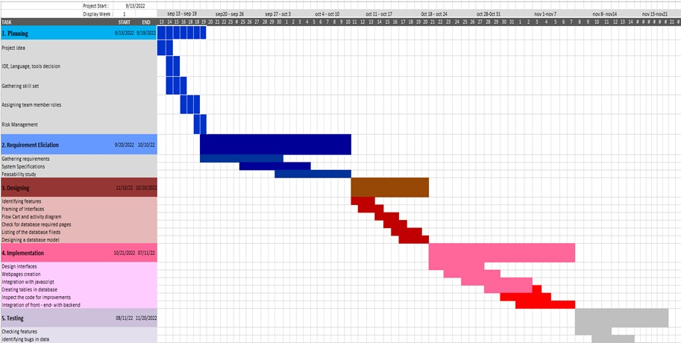

**Risk Management:**

In our group discussion while analysing the project requirements we identified the following major risks.

1. Some members of the group lack programming in Java to accomplish certain tasks.

2. Difficulties in implementing the proper database design for the application.

3. Since our project involves seven modules like Admin, Manager, Student, Time Sheet, Payroll, Bank and Reports therefore integration between these modules may involve some mistakes.

4. Developing application by group members at different timings leads to delay in achieving the tasks.

**Plan on monitoring the risks:**

1. **Know about language and functionalities:**

Ask all members of group to have good knowledge on the technologies (JAVA, HTML, JS etc) using in developing the project. If any member in the group having problems with the language or technologies for any functionality while developing must be informed to team leader so that the team leader or ask any other member in the group to give some suggestions to help in solving the problem.

1. **Database Design**

It is one of the major parts of the process of developing the application. Hence it should be designed with all group members and everybody should have proper idea on the relations of tables.

1. **Monitoring schedule and daily follow-ups:**

Having every day follow up about the status of each progress of all members task would result in avoiding missing deadlines.

1. **Developing Time**

Select a particular time in a day so that members implement the features at the same time and any issues come can be rectified on the spot.

**Plan on revaluation of risks:**

Every week a meeting is conducted with the group members so that members can share their views about new features that can be added and problems with existing features. Any problem they get which is hard to rectify then members can go with alternate solutions.

**Contingency plans:**

**1. Deadlines not met:** Making sure that if the work cannot be done in the specified time, taking help from other teammates who are available to help. The group leader can assign more members to work on a specified task to ensure it is delivered on time

**2. Referencing of the variables:** If there is any error found while retrieving the variable values, the changes must be made immediately and should be conveyed to the members so that necessary changes at other places can be done. Thorough testing should be done to minimize these errors to as little as we can.

**Team Roles:**

1. **Vaishnavi Mandadi(Group Leader)**

* Design of UI, Middle layer integration from backend to frontend and frontend to backend.

1. **Kiran jyothi bodduluri**

* Design of UI, Backend Integration and E-R diagrams.

**3. Sahit Reddy Chinthakuntla**

* Implementing UI Design, PPT , Creating Database table and Writing test files.

1. **Rajashekhar Reddy Moddu**

* Gathering required resources, Design of UI, UML diagrams creation.

1. **Venkata Sai Reshma kallepalli**

* Design of UI, Backend Integration, Documentation and PPT.

1. **Akshaya Sampelli**

* Design of UI, Scheduling meetings, PPT, Gantt Chart.

1. **Aishwarya Yadav Jala**

* UI design, requirement specification, Testing, Documentation and UML diagrams.

**Member Contribution Table (For Deliverable 1):**

|  |  |  |  |
| --- | --- | --- | --- |
| Member Name | Contribution Description | Overall Contribution | Note |
| Vaishnavi Mandadi | As the leader of the team,I have organized zoom meetings and we have discussed about project ideas, planning and decided a schedule for coming weeks . I have created all the files required in git hub repository during the zoom calls .We have distributed the work equally among ourselves. I have also updated my Kanban board. I contributed my ideas for planning of the project and risk management and worked on the project deliverable. | 15% |  |
| Aishwarya Yadav Jala | I have worked on project idea proposal ,attended the zoom meetings, Worked on github readme file and on meeting minutes file.prepared the documentation | 13% |  |
| Kiran Jyothi Bodduluri | I have worked on ppt first few slides , helped on working with Gantt chart, Attended the zoom meetings, participated in group discussions and gave some ideas. | 12% |  |
| Venkata Sai Reshma Kallepalli | I have worked on Gantt chart , helped in making the ppt slides,I have contributed my thoughts for risk management, worked on features and functionalities in deliverable 1 | 12% |  |
| Akshaya Sampelli | I have scheduled the group meetings ensured the participation of each member, I have worked on Gantt chart as well, I have gathered information about admin and manager module. Made the final changes to the ppt | 12% |  |
| Sahit Reddy Chinthakuntla | Shared few ideas about the implementation and worked on few modules student and time sheet module. | 12% |  |
| Rajashekhar Reddy Moddu | Helped on finalsing the project, worked on bank and report module, helped in submitting all the documents in canvas. | 12% |  |